AI LAB 01 TASKS
FASIH AHMED 24K-0956 BCS-4B
TASK 01 ( SOURCE CODE):
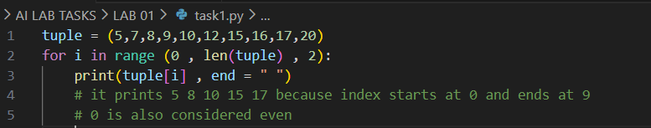
OUTPUT:
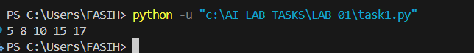
TASK 02 (SOURCE CODE):
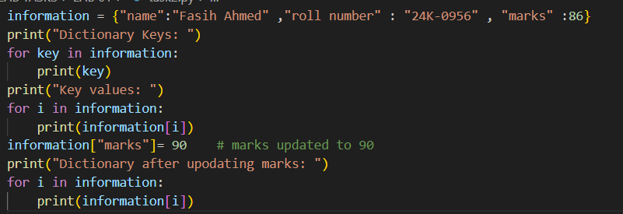
OUTPUT:
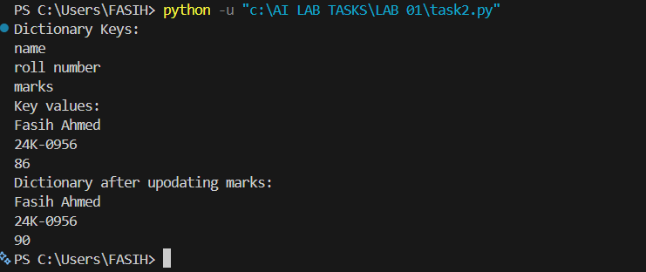
TASK 03 (SOURCE CODE):
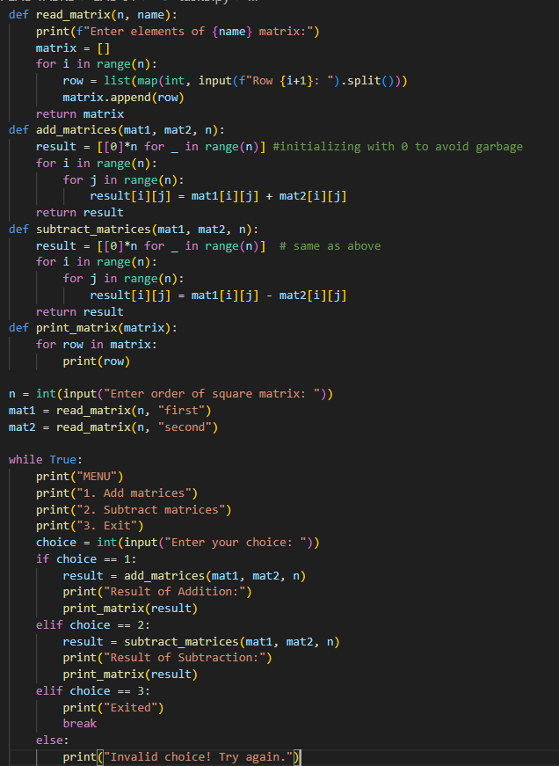
OUTPUT:
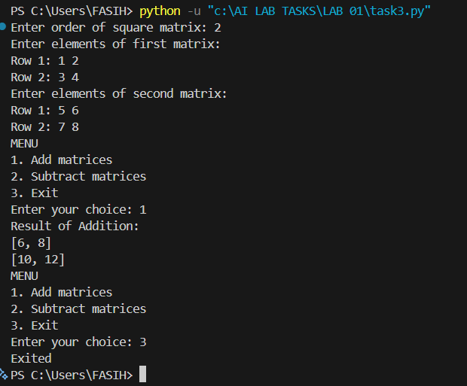
TASK 04 (SOURCE CODE):
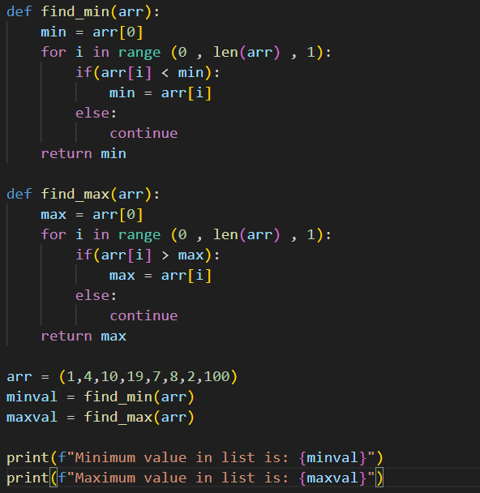
OUTPUT:
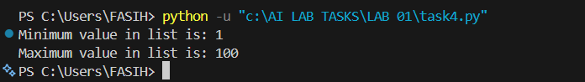
TASK 05 (SOURCE CODE):
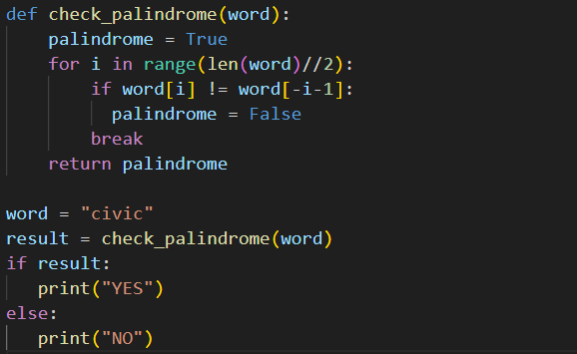
OUTPUT:
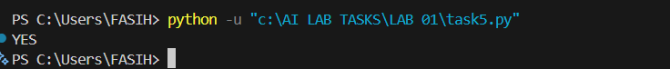
TASK 06 (SOURCE CODE):
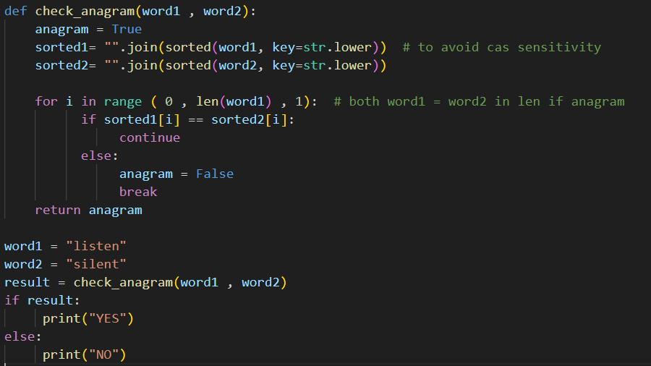
OUTPUT:

>>>>>>>>>>>>>>>>>>>>>>>>>>>>>>>THE END<<<<<<<<<<<<<<<<<<<<<<<<<<<<<<<

